Summary of Week One

We did not get quite as far as we would like for day one, but we achieved nearly all of our goals.

We have Eclipse installed, we have added WPILIB, which is used for the FRC Robot programs, and we have copied two sets of libraries that I had called out in the build file we are going to use. We talked about the build file a bit, but what does it really do? Traditionally, you start programming by creating a Hello World program.

Let’s do that.

We will copy some text for our program, open up a command line, enter a command to copy the things we type to a file named HelloWorld.Java, and then we will have java perform the commands in the file.

Select the text between these two lines, right click on it, and select “Copy” from the popup menu.

------ Start after this line ----------------  
*/\*\*\*\*\*\*\*\*\*\*\*\*\*\*\*\*\*\*\*\*\*\*\*\*\*\*\*\*\*\*\*\*\*\*\*\*\*\*\*\*\*\*\*\*\*\*\*\*\*\*\*\*\*\*\*\*\*\*\*\*\*\*\*\*\*\*\*\*\*\*\*\*\*\*\*\*\*\**

*\* Compilation: javac HelloWorld.java*

*\* Execution: java HelloWorld*

*\**

*\* Prints "Hello, World". By tradition, this is everyone's first program.*

*\**

*\* % java HelloWorld*

*\* Hello, World*

*\**

*\* These 17 lines of text are comments. They are not part of the program;*

*\* they serve to remind us about its properties. The first two lines tell*

*\* us what to type to compile and test the program. The next line describes*

*\* the purpose of the program. The next few lines give a sample execution*

*\* of the program and the resulting output. We will always include such*

*\* lines in our programs and encourage you to do the same.*

*\**

*\*\*\*\*\*\*\*\*\*\*\*\*\*\*\*\*\*\*\*\*\*\*\*\*\*\*\*\*\*\*\*\*\*\*\*\*\*\*\*\*\*\*\*\*\*\*\*\*\*\*\*\*\*\*\*\*\*\*\*\*\*\*\*\*\*\*\*\*\*\*\*\*\*\*\*\*\*\*/*

public class HelloWorld {

public static void **main**(String[] args) {

*// Prints "Hello, World" to the terminal window.*

System.out.**println**("Hello, World");

}

}

------ Stop before this line ----------------

Copy the lines below and open up a command prompt. Just click on your windows start icon and type “cmd.exe” – you should see a prompt like this:

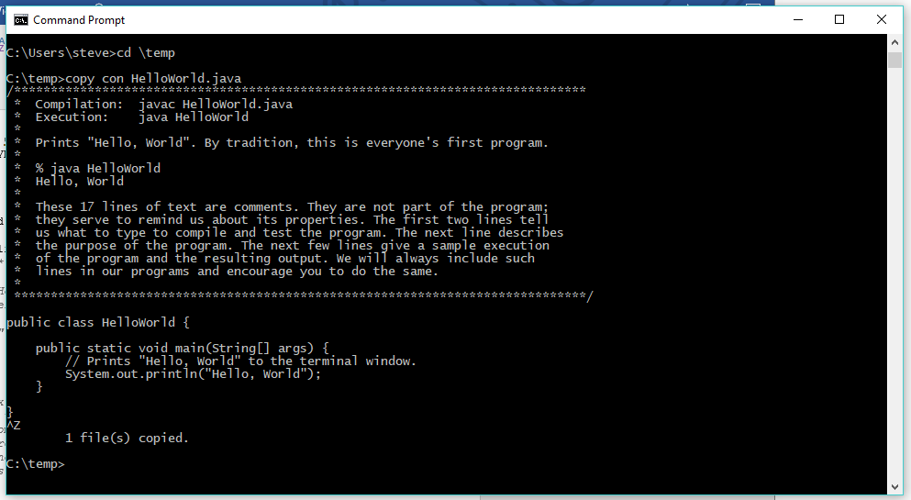

I keep my junk in a directory called temp on the c: drive. The command cd \temp changes your focus to that directory. Type the command

Copy con HelloWorld.java

Click with your right mouse button and the data in your paste buffer will be copied to that file. Press the <Ctrl-Z> key to end the input stream. If you did all those steps correctly, you will have a file named HelloWorld.Java in the temp directory.

You have a Java Compiler in your Program Files directory where you stored the Java Development Kit. On my system, it is in “C:\Program Files\Java\jdk1.8.0_131\bin”

In that command prompt I am going to type

“C:\Program Files\Java\jdk1.8.0_131\bin\javac.exe” HelloWorld.java

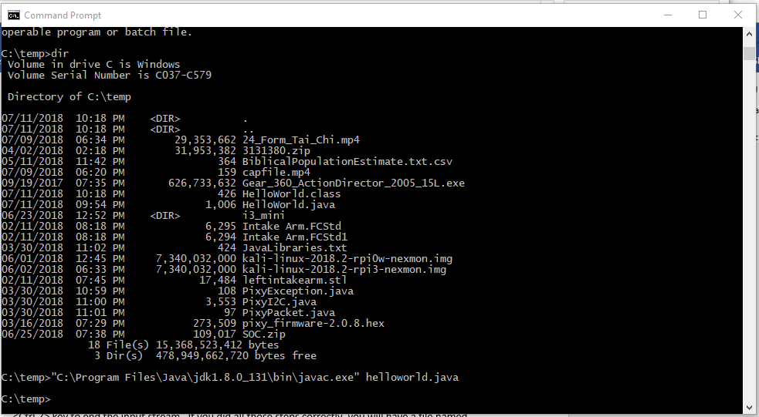

When that command finishes, I will find a file HelloWorld.class in my temp directory. I type the command

“C:\Program Files\Java\jdk1.8.0_131\bin\java.exe” HelloWorld

And I see my “Hello, World” Indicating that I have done everything well enough to compile and execute java programs. Note the capitalization.